**FIRE ALARMING SYSTEM**

|  |  |  |
| --- | --- | --- |
| Rushikesh Tayade | Sahil Pote | Ankit Shahane |
| Information Technology | Information Technology | Information Technology |
| Engineering (B.E.) | Engineering (B.E.) | Engineering (B.E.) |
| Vidyalankar Institute of | Vidyalankar Institute of | Vidyalankar Institute of |
| Technology | Technology | Technology |
| Maharashtra, India | Maharashtra, India | Maharashtra, India |
| [rushikesh.tayade@vit.edu.in](mailto:rushikesh.tayade@vit.edu.in%20) | [sahil.pote@vit.edu.in](mailto:sahil.pote@vit.edu.in) | [ankit.shahane@vit.edu.in](mailto:ankit.shahane@vit.edu.in) |

**Abstract-**

***Fire alarm systems are essential in alerting people before fire engulfs their homes. However, fire alarm systems, today, require a lot of wiring and labor to be installed. This discourages users from installing them in their homes. Therefore, we are proposing an IoT based wireless fire alarm system that is easy to install. The proposed system is an ad-hoc network that consists of several nodes distributed over the house. Each of these nodes consists of a microcontroller (ESP8266 nodeMCU) connected to flame sensors that continuously sense the surrounding environment to detect the presence of fire. The nodes create their own Wi-Fi network. Once fire is detected by a node, it sends a signal to a centralized node that is triggered to send an Notification to the fire department and the user. A prototype was developed for the proposed system and it carried out the desired functionalities successfully with an average delay of less than 10 seconds.***

**I. INTRODUCTION**

Having a fire alarm system is essential to ensure the safety of the people’s life and reduce the number of losses as much as possible. However, most of the homes lack these fire alarm systems, which might put residents into risk when fire breaks out in their home, either in their presence or absence.

A wireless sensor network (WSN) is a self-configuring wireless network with minimal infrastructure that monitors physical or environmental conditions for flames, contaminants and transmits data via the network's first place. Or a receiver that can observe and analyze data. The receiver or base station serves as the interface between the user and the network. By entering a query and collecting the results from the recipient, you can get the information you need from the Internet. A wireless sensor network usually has thousands of sensor nodes. Sensor nodes can communicate with each other via radio signals. Wireless sensor nodes are equipped with sensitive equipment and computing equipment, radio transmitters and power supply components.

**II. PROBLEM STATEMENT**

Having a fire alarm system is essential to ensure the safety of the people’s life and reduce the number of losses as much as possible. However, most of the homes lack these fire alarm systems, which might put residents into risk when fire breaks out in their home, either in their presence or absence.

Hence, we came up with a Fire Alarming System that monitors if flames are being produced nearby of the residence, the temperature of the surroundings are watched. Using this information we can send notification to appropriate authorities.

**III. METHODOLOGY**

Based on our problem statement, we have created a prototype to implement a fire alarming system considering all the risk that comes when fire breaks out. The main components of the project are NodeMCU, flame sensor, 12v DC fan,

and relay module.

Using ARDUINO IDE software we can program NodeMCU in such a way that it helps us to send notifiacation to authorities when fire breaks out in that area. The notification will be received by user on blynk app if the fire breaks. In case the fire break out, NodeMCU will send notification to respective person as well as it will turn on an 12v DC fan to demonstrate how we can take preliminary actions in case of actions with the help of Relay.\

**IV. COMPONENTS USED**

***A. NodeMCU***

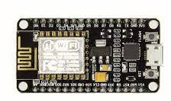

NodeMCU is an Internet of Things (IoT)-focused open-source Lua-based firmware and development board. It includes software for Espressif Systems’ ESP8266 Wi-Fi SoC as well as hardware for the ESP-12 module.The major argument for choosing this is that it is cheap and includes a built-in Wi-Fi module. Because it is similar to Arduino, it can be programmed using the ArduinoIDE software. It has ten General Purpose Input/Output pins for connecting to external devices. A standard NodeMCU, complete with pin numbers.

***B. Flame Sensor***

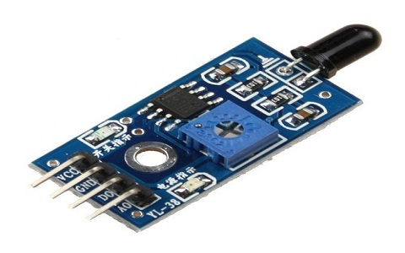

A sensor which is most sensitive to a normal light is known as a flame sensor. That’s why this [sensor module](https://www.elprocus.com/accelerometer-sensor-working-and-applications/) is used in flame alarms. This sensor detects flame otherwise wavelength within the range of 760 nm – 1100 nm from the light source. This sensor can be easily damaged to high temperature. So this sensor can be placed at a certain distance from the flame. The flame detection can be done from a 100cm distance and the detection angle will be 600. The output of this sensor is an analog signal or digital signal. These sensors are used in fire fighting robots like as a flame alarm.

A flame-sensor is one kind of detector which is mainly designed for detecting as well as responding to the occurrence of a fire or flame. The flame detection response can depend on its fitting. It includes an alarm system, a natural gas line, propane & a fire suppression system. This sensor is used in industrial boilers. The main function of this is to give authentication whether the boiler is properly working or not. The response of these sensors is faster as well as more accurate compare with a heat/smoke detector because of its mechanism while detecting the flame.

***D. Relay Module***



The relay module is an electrically operated switch that can be turned on or off deciding to let current flow through or not. They are designed to be controlled with low voltages like 3.3V like the ESP32, ESP8266, etc, or 5V like your Arduino

**V. WORKING**

With the help of the fire alarming system, we will get notified remotely if fire gets detected in the surroundings using flame sensor

Flame sensor will continuously check the surroundings for flames or any fire symptoms if found it will notify the NodeMCU.

Flame sensor has two Boolean output values which are 0 and 1. If the flame is not detected in the surrounding it will send the value 0 and vice versa.

NodeMCU is acts as WIFI module which is connected to the local WIFI and will send the notification to the cloud if flame detected.

After flame gets detected we also turn on 12v DC fan to demonstrate how we can implement preliminary precautions in case of fire.

**CIRCUIT DIAGRAM**

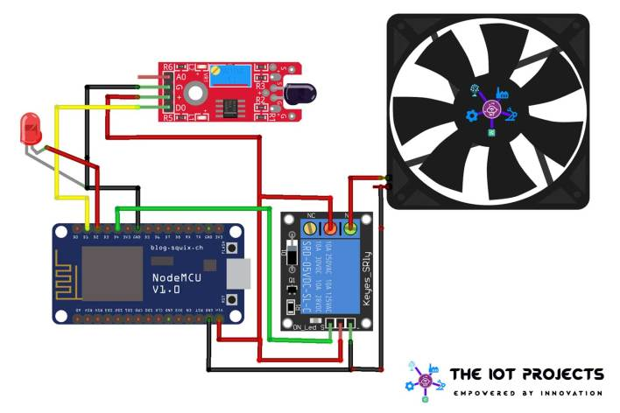

**VI. CONCLUSION**

From this work, we can sense the fire in the surrounding and can notify as well as take preliminary actions to prevent it. Depending upon the flame sensors reading the 12v DC fan can be turned on automatically which demonstrate the actions which can be taken. This saves danger of risking live in case of fire, in case of danger concern authorities can be remotely notified so that the required actions can be taken accordingly. Also 12v DC fan works as preliminary actions can be taken with help of relay module.

This project will save lives in case of fire in corporate building as well as societies. We have taken care of the notification system such as a notification will be sent to authorities after the delay of 500 ms if fire is still there.

**VII. ACKNOWLEDGEMENT**

We would like to express our deepest appreciation to all those who provided us the possibility to complete this report. We express our profound gratitude to our Prof. Vinita Bhandiwad Ma’am, our respectable project guide, for her gigantic support and guidance. Without her counselling our project would not have seen the light of the day

We extend our sincere thanks to Dr. Vipul Dalal, Head of the Department of Information Technology for offering valuable advice at every stage of this undertaking.

We would like to thank all the staff members who willingly helped us. We are grateful to VIDYALANKAR INSTITUTE OF TECHNOLOGY for giving us this opportunity.

The days we have spent in the institute will always be remembered and also be reckoned as guiding in our career.